BEVERLY HILLS HIGH SCHOOL PERFORMING ARTS DEPARTMENT presents
LES MISÉRABLES – SCHOOL EDITION
APRIL 2ND THROUGH 5TH, 2008

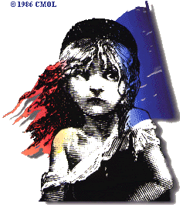

TICKET ORDER FORM
(please print all information clearly!)

NAME:____________________________________________________________________________________

PHONE NUMBER(S):______________________________________________________________________

DATE(S) REQUESTED | WED.  4/2  2:00 PM | THU.  4/3  7:30 PM | FRI.  4/4  7:30 PM | SAT.  4/5  1:00 PM | SAT.  4/5  7:30 PM | TOTAL COST
# OF ADULT TICKETS  @ $15.00 EACH ($6.00 ON WED. 4/2 ONLY) | ________ | ________ | ________ | ________ | ________ | ________
# OF STUDENT TICKETS @ $10.00 EACH |  | ________ | ________ | ________ | ________ | ________
# OF “VIP” TICKETS @ $25.00 EACH (FIRST SEVEN ROWS, THURS. 4/3 – SAT. 4/5) |  | ________ | ________ | ________ | ________ | ________
TOTAL COST OF ORDER: |  |  |  |  |  | ________

Payment must be made by check payable to BHHS Performing Arts Dept. – “Les Mis”. Please mail your ticket order and payment to:
Les Mis c/o Herb Hall
Beverly Hills High School
241 Moreno Dr.
Beverly Hills, Ca. 90212

Seat locations will be determined on a first-come, first-served basis. Mailed ticket orders must be received by Monday, March 31, 2008. Tickets will be held at will-call. Tickets will also be sold at each performance, subject to availability. For more information, call (310) 551-5100, extension 8459. Thank you.

